Name #_________ Date ____________________________
Mid Module 5 Class Review
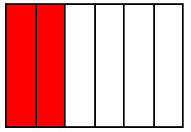
- Let each small square represent $\frac{1}{6}$. (NF.3)

Example: $\frac{2}{6}$
$= \frac{1}{6} + \frac{1}{6}$
  - Using the same unit, draw and shade the following fractions.
Represent each as a sum of unit fractions.

i. 1 ii. $\frac{3}{6}$ iii. $\frac{8}{6}$

  - Decompose the fractions using only 2 addends. (NF.3)

$\frac{6}{6}$= + $\frac{8}{6}$ = +

  - Rewrite the equations from Part (a) as the multiplication of a whole number by a unit fraction. (NF.4)

1 =

$\frac{2}{6}$ =

$\frac{8}{6}$ =

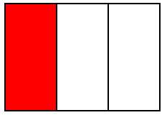  2a. Using the fractional units shown, identify the fraction of the rectangle that is shaded. Continue this pattern by drawing the next area model in the sequence and identifying the fraction shaded. (NF.1)  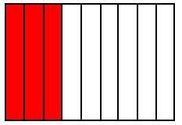 | b. Use multiplication to explain why the first two fractions are equivalent. (NF.1)

3. Cross out the fraction that is not equivalent to the other three. Show how you know. (NF.1)
a. $\frac{3}{4} \frac{6}{8} \frac{30}{40} \frac{8}{4}$ b. $\frac{6}{4} \frac{3}{2} \frac{12}{18} \frac{8}{4}$

4. Fill in the circle with <, =, or > to make a true number sentence. Justify each response by drawing a model (such as an area model or a number line). (NF.2)

a. $\frac{5}{5}$ $\frac{12}{12}$ b. $\frac{12}{18}$ $\frac{11}{6}$

c. $\frac{7}{4}$ $\frac{9}{6}$ d. $\frac{5}{12}$ $\frac{6}{10}$

- Fill in the blanks to make each number sentence true. Draw a number line, a tape diagram, or an area model to represent each problem. (NF.3)

a. ________ = $\frac{53}{100}- \frac{27}{100}$ b. $\frac{6}{12}+$_______ = 1

c. $\frac{2}{8} + \frac{5}{8} + \frac{3}{8} =$ _______ d. $1-\frac{4}{7}=$______

6. Amira, Angela, and Serena went shopping.
- They spent $\frac{2}{7}$ of their money on drinks, $\frac{3}{7}$ of their money on lunch, and the rest on stickers. What fraction of their money was spent on stickers? Draw a model, and write an equation to solve. (NF.3)

- Amira noticed her drink was $\frac{1}{4}$ full and Angela’s was $\frac{1}{2}$ full. Amira said, “My $\frac{1}{4}$ full bottle has more water than your $\frac{1}{2}$ full bottle.” Was Amira accurate in her statement? Explain in words or a model. (NF.2)

- Amira, Angela, and Serena each had identical containers of stickers. Amira used $\frac{2}{6}$ container. Angela used $\frac{4}{6}$ container, and Serena used $\frac{5}{6}$ container. How many total containers of stickers did they use? (NF.3)

- Eight out of the twelve stickers were hearts. What is another fraction equal to 8 twelfths? Write a number sentence, and draw a model to show the two fractions are equal. (NF.1)

