Name #_________ Date ____________________________
Mid Module 5 Homework Review
- Let each small square represent $\frac{1}{3}$. (NF.3)
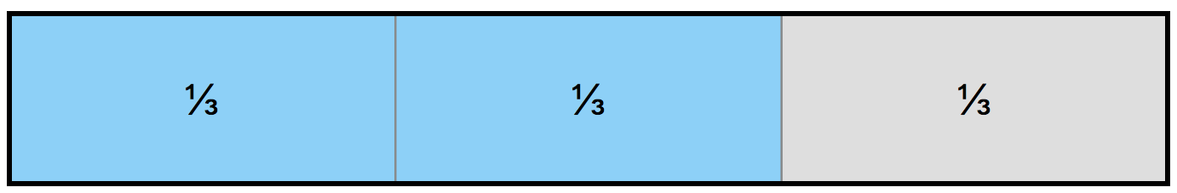

Example: $\frac{2}{3}$
$= \frac{1}{3}+ \frac{1}{3}$
  - Using the same unit, draw and shade the following fractions.
Represent each as a sum of unit fractions.

i. $\frac{3}{3}$ ii. $\frac{4}{3}$ iii. $\frac{6}{3}$

  - Decompose the fractions using only 2 addends. (NF.3)

$\frac{3}{3}$= + $\frac{6}{3}$ = +

  - Rewrite the equations from Part (a) as the multiplication of a whole number by a unit fraction. (NF.4)

$\frac{3}{3}$ =

$\frac{4}{3}$ =

$\frac{6}{3}$=

2a. Using the fractional units shown, identify the fraction of the rectangle that is shaded. Continue this pattern by drawing the next area model in the sequence and identifying the fraction shaded. (NF.1)  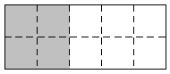 | b. Use multiplication to explain why the first two fractions are equivalent. (NF.1)

3. Cross out the fraction that is not equivalent to the other three. Show how you know. (NF.1)
a. $\frac{12}{6} \frac{20}{4} \frac{10}{2} \frac{40}{8}$ b. $\frac{2}{3} \frac{20}{30} \frac{10}{15} \frac{14}{20}$

4. Fill in the circle with <, =, or > to make a true number sentence. Justify each response by drawing a model (such as an area model or a number line). (NF.2)

a. $\frac{7}{5}$ $\frac{5}{5}$ b. $\frac{6}{8}$ $\frac{6}{10}$

c. $\frac{9}{3}$ $\frac{18}{6}$ d. $\frac{13}{8}$ $\frac{10}{6}$

- Fill in the blanks to make each number sentence true. Draw a number line, a tape diagram, or an area model to represent each problem. (NF.3)

a. ________ = $\frac{4}{10} + \frac{5}{10}$ b. $\frac{5}{6}- \frac{4}{6}$ = _______

c. $\frac{8}{16} + \frac{6}{16} + \frac{3}{16} =$ _______ d. $1-\frac{3}{4}=$______

6. William, Alex, and Dylan went to the game shop.
- They spent $\frac{1}{8}$ of their money on steam cards, $\frac{4}{8}$ of their money on candy, and the rest on games. What fraction of their money was spent on stickers? Draw a model, and write an equation to solve. (NF.3)

- William noticed his candy bag was $\frac{1}{4}$ full and Angela’s was $\frac{2}{4}$ full. William said, “My $\frac{1}{4}$ full bag has more candy than your $\frac{2}{4}$ full bag.” Was William accurate in his statement? Explain in words or a model. (NF.2)

- William, Alex, and Dylan each had identical containers of sour gummies. William ate $\frac{3}{4}$ of his gummies. Alex ate $\frac{2}{4}$ of his gummies, and Dylan ate $\frac{3}{4}$ of his gummies. How many total containers of gummies did they eat? (NF.3)

- Four out of the six gummies they picked were blue. What is another fraction equal to 4 sixths? Write a number sentence, and draw a model to show the two fractions are equal. (NF.1)

