The Great Kindness Challenge

- Complete 30 kind acts during the week of February 12-15.
- Turn in your challenge form to your teacher.
- Your name will appear on the Camarena Kindness Wall!

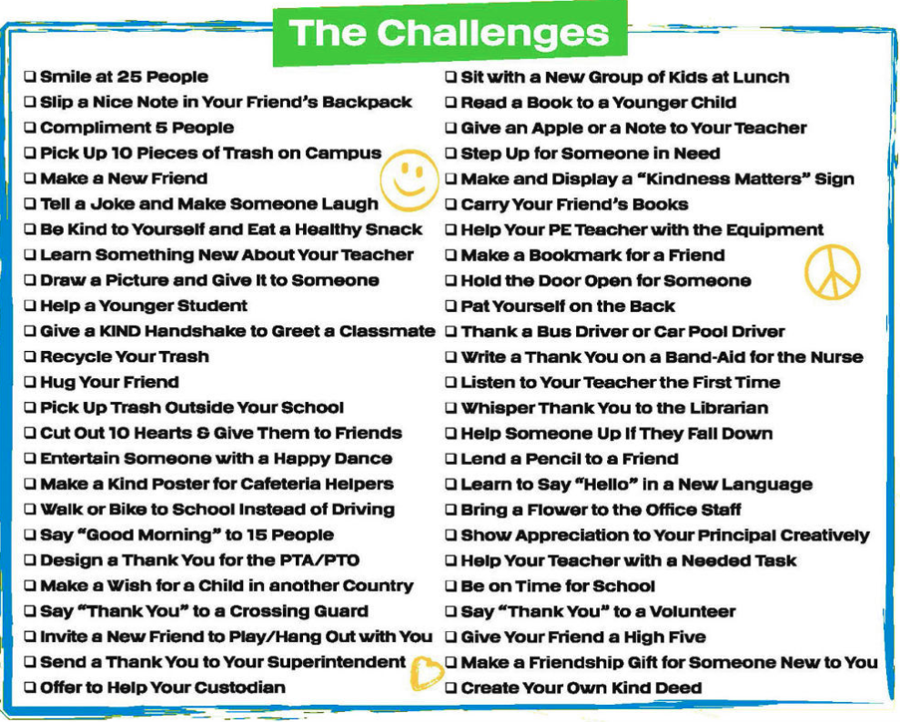

Your Name: ________________________________ Your Room Number: _________

My child has completed 30 acts of kindness!

Parent Signature: __________________________________________

